**Sales Invoice generator**

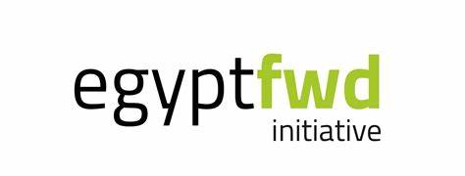

**Name: Fady Raoof**

**Email: fady.raoof@msa.edu.eg**

This project help user to generate his full purchases in one Invoice has all his record of items the user boughs from any super market that help the user to know each item quantity and total of each item separately and total price of all those items after calculate the quantity of each item that facilitate the user to know all the items price and the total of it not only that but also save those data which contain all item information and customer name and date in two csv files.